Do your PART:  Prepared  And  Respectful  Together | Classroom  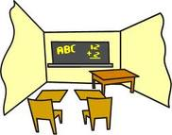 | Lunchroom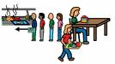 | Bus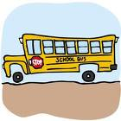 | Hallway  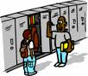 | Recess  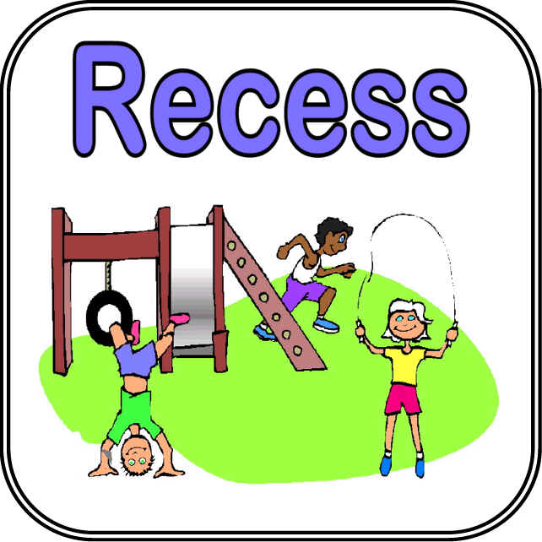 | Bathroom  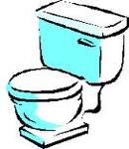 | Locker Room  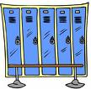
DO YOUR PART FOR:  Self | Always give your best effort.  Arrive on time.  Be prepared. | Eat your own food.  Walk.  Be prepared.  Follow directions. | Face forward.  Stay in your seat.  Wait for the bus to stop before exciting. | Walk.  Use soft voices. | Play by the rules.  Be on time to line up.  Get help when needed. | Keep to yourself.  Budget your time.  Use sink, soap, dryers, and toilets correctly.  Use proper hygiene. | Dress, lock your locker and get into gym quickly.  Give everyone his or her personal space.
DO YOUR PART FOR:  Others | Speak when it is your turn.  Clean up your area. | Clean up your area.  Use soft voices.  Hands and feet to yourself in line and at the table. | Hands and feet to yourself.  Listen to the driver.  Use kind words and soft voices. | Keep hands and feet to self.  Stay on the right.  Keep hallway clean. | Play by the rules.  Keep hands and feet to yourself.  Listen to recess supervisor. | Give privacy to others.  Use soft voices.  Keep bathroom clean. | Keep only your own belongings in your locker.  Give everyone his or her own personal space.

