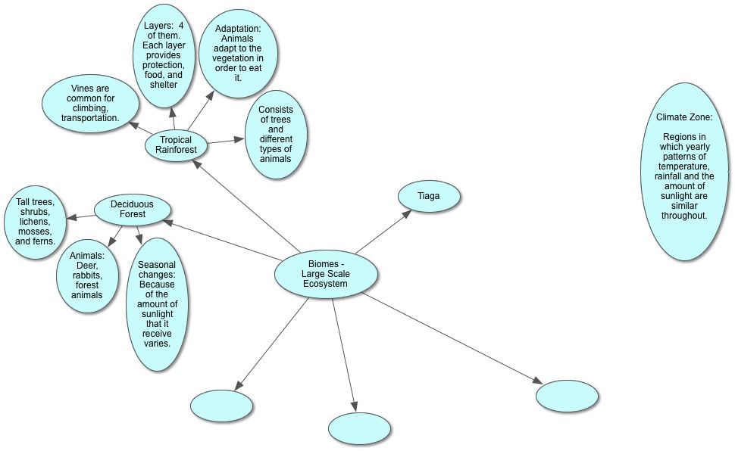

Biomes -
Large Scale Ecosystem
I. Tiaga
II.
III. Tropical Rainforest
A. Adaptation: Animals adapt to the vegetation in order to eat it.
B. Consists of trees and different types of animals
C. Layers: 4 of them. Each layer provides protection, food, and shelter
D. Vines are common for climbing, transportation.
IV. Deciduous Forest
A. Tall trees, shrubs, lichens, mosses, and ferns.
B. Animals: Deer, rabbits, forest animals
C. Seasonal changes: Because of the amount of sunlight that it receive varies.
V.
VI.
Climate Zone:

Regions in which yearly patterns of temperature, rainfall and the amount of sunlight are similar throughout.

